1. Create Web Pages like the following using tables:  
     
     
   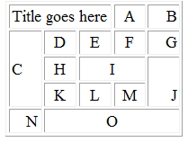
2. Create a Web Page like the following using forms:  
     
   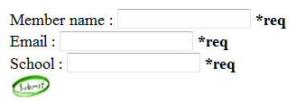
3. Create a Calculator-like table. You should use a HTML 5 form for the Calculator  
   -Buttons for all the numbers  
   and operators (+, -, etc.)  
   -Textbox for the result  
   -Do not make the same styles  
   as the example.  
   